**Coding Challenge SQL- 3**

**Crime Management**

* **Crime Management Shema DDL and DML**

1. **Create database**

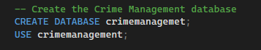

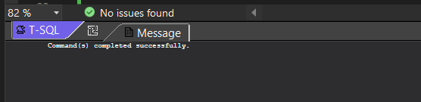

1. **Create and view tables**

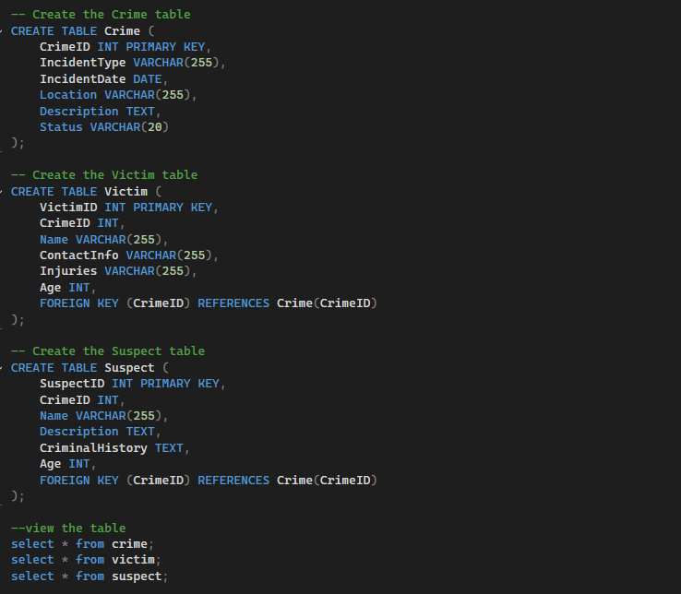

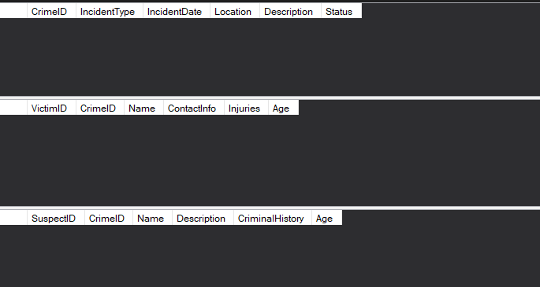

1. **Insert data into respective tables**

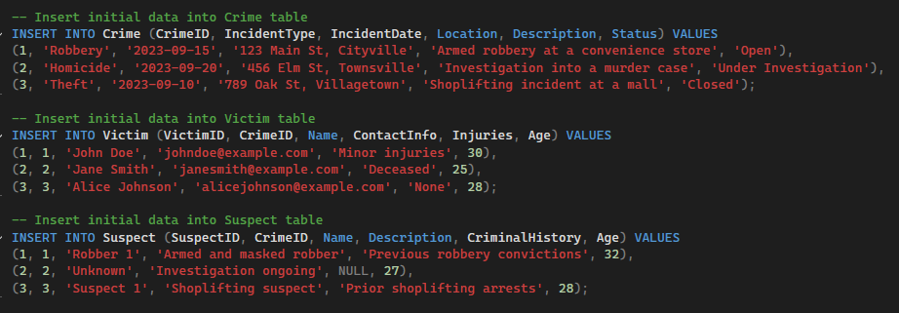

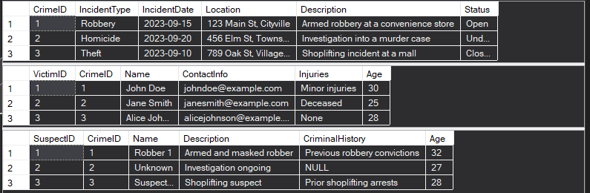

**4. Insert Additional data to support all queries**

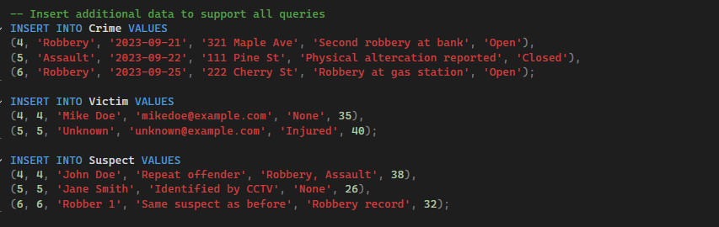

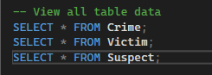

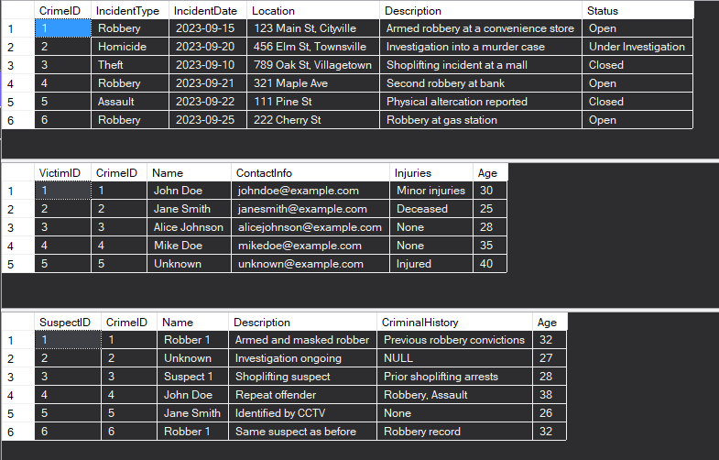

* **Tasks to solve the below queries:**

1. **Select all open incidents.**



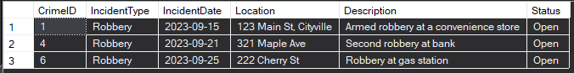

1. **Find the total number of incidents.**





**3. List all unique incident types.**



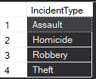

**4. Retrieve incidents that occurred between '2023-09-01' and '2023-09-10'.**





**5. List persons involved in incidents in descending order of age.**

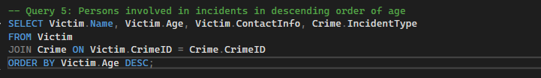

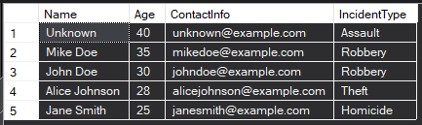

**6. Find the average age of persons involved in incidents.**





**7. List incident types and their counts, only for open cases.**

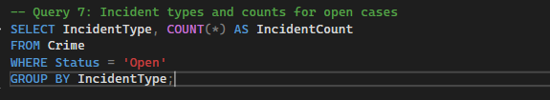



**8. Find persons with names containing 'Doe'.**



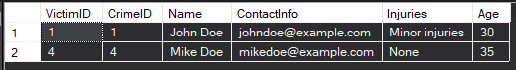

**9. Retrieve the names of persons involved in open cases and closed cases.**

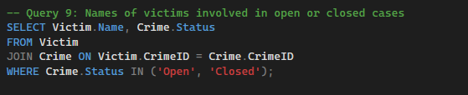

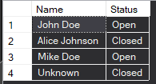

**10. List incident types where there are persons aged 30 or 35 involved.**

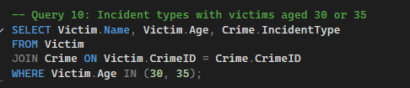

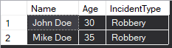

**11. Find persons involved in incidents of the same type as 'Robbery'.**

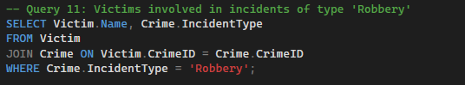

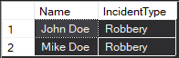

**12. List incident types with more than one open case.**

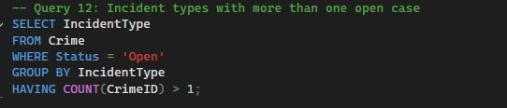



**13. List all incidents with suspects whose names also appear as victims in other incidents.**

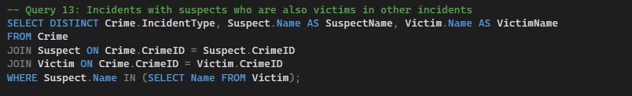

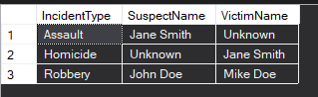

**14. Retrieve all incidents along with victim and suspect details.**

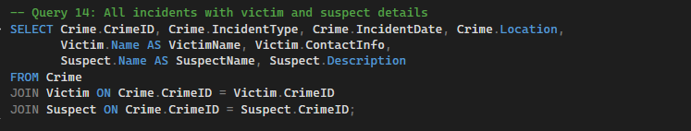

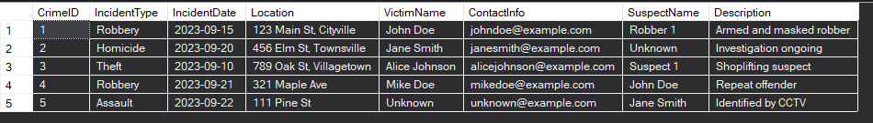

**15. Find incidents where the suspect is older than any victim.**

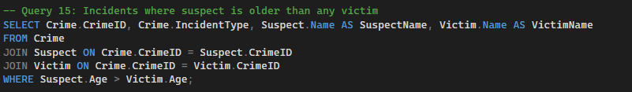

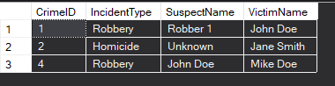

**16. Find suspects involved in multiple incidents.**

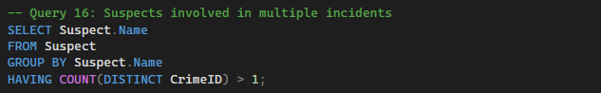



**17. List incidents with no suspects involved.**

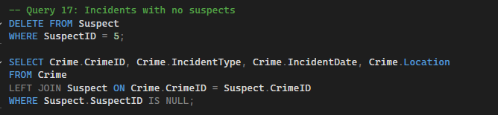

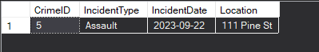

**18. List all cases where at least one incident is of type 'Homicide' and all other incidents are of type 'Robbery'.**

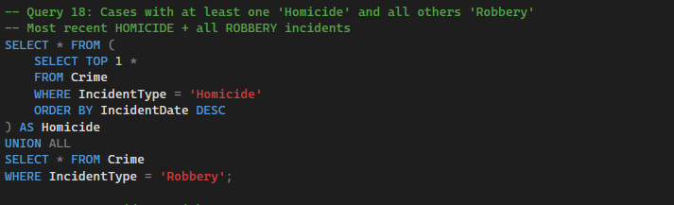

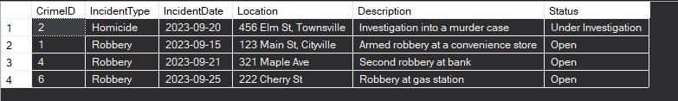

**19. Retrieve a list of all incidents and the associated suspects, showing suspects for each incident, or 'No Suspect' if there are none.**

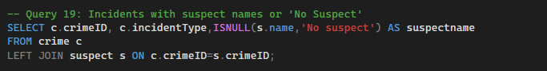

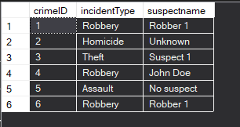

**20. List all suspects who have been involved in incidents with incident types 'Robbery' or 'Assault.**

